Name:_________________________________________

Teacher: _______________________________________

Class: ____________________________

CC number: ___________________

MATHEMATICS

YEAR 9 EXAM

SEMESTER ONE 2015

Section Two: Resource Allowed

TIME ALLOWED FOR THIS PAPER
Reading time before commencing 3 minutes.
Working time for paper 52 minutes.

MATERIAL(S) REQUIRED / RECOMMENDED FOR THIS PAPER
TO BE PROVIDED BY THE CANDIDATE:
Standard items: pens, pencils, pencil sharpener, eraser, correction fluid, ruler, highlighters.

Special items: Scientific Calculator, 1 x A4 sheet of notes, formula sheet

Important note to candidates:
No other items may be used in this section of the examination. It is your responsibility to ensure that you do not have any unauthorised notes or other items of a non-personal nature in the examination room. If you have any unauthorised material with you, hand it to the supervisor before reading any further.
TO BE PROVIDED BY THE SUPERVISOR:
This Question / Answer Booklet

Instructions to candidates
- Candidates are to remain seated during the exam and are not allowed to talk to other candidates.
- Mobile phones are not to be used at all during the exam.
- Students who fail to follow examination rules will be removed and dealt with in accordance to the schools policy.

Write your answers in the spaces provided in this Question/Answer Booklet. Spare pages are included at the end of this booklet. They can be used for planning your responses and/or as additional space if required to continue an answer.
- Planning: If you use spare pages for planning, indicate this clearly at the top of the page
- Continuing an answer: If you need the space to continue an answer, indicate in the original answer space where the answer is continued, i.e. give the page number. Fill in the number of the question(s) that you are continuing to answer at the top of the page.

Show all your working clearly. Your working should be sufficient to allow your answers to be checked readily and for marks to be awarded for reasoning. Incorrect answers given without supporting reasoning cannot be allocated any marks. For any question or part question worth more than two marks, valid working or justification is required to receive full marks. If you repeat an answer to any question, ensure that you cancel the answer you do not wish to have marked.

Use a blue or black pen only, except with diagrams where you should use pencil.

Question | Out of | Mark
20 | 4
21 | 5
22 | 6
23 | 5
24 | 5
25 | 3
26 | 3
27 | 7
28 | 4
29 | 8
30 | 5
31 | 4
32 | 6
TOTAL | 65
 | Mark
Percentage
Overall Percentage

- Decide if the statements below are true or False

  - $360 000 000$ in scientific notation is $3.6×{10}^{8}$ ______

  - 5.2 million in scientific notation is 52$×{10}^{6}$ ______

  - $2×{10}^{-2}$ as a decimal number is$200$ ______

  - $6.1×{10}^{1}$ as a decimal number is 6.1

[4 marks]
- Simplify the following expressions

  - $2ab×5bc$

  - $4a-7a^{2}b+5a+2a^{2}b-2b$

[5 marks]

  - The volume of the Moon is 21960000000 km³. Write this measurement using scientific notation.

  - The volume of Earth is 1.083 × 10¹² km³. Write this measurement in decimal form.

  - What proportion of the Earth’s volume is the Moon? Write your answer using scientific notation and rounding to three significant figures.

[6 marks]

- Expand the following, simplifying when possible.

  - $3(x+3)$

  - $2x(x-5)$

  - $5\left(y-1\right)+3(4-y)$

[5 marks]

- Fully factorise the following expressions

  - $10f-25$

  - $6p^{2}+18p$

  - $2t^{2}+8tu-20tv$

[5 marks]

- Simplify the following:

  - $3^{7}×3^{9}$

  - $p^{10}÷p^{4}$

  - ${\left(t^{3}\right)}^{4}$

[3 marks]

- Simplify the following expressions:

  - 3a²b⁴ × 4a³b

  - $\frac{15p^{5}q^{8}}{9pq^{4}}$

[3 marks]

- Simon chooses two letters from the word MATH without replacement.

  - Draw a diagram listing all possible outcomes.

  - Find:
    - Pr(of getting either an M or an A) =

    - Pr(exactly HT) =

  - If the first letter drawn was replaced before the second letter was drawn, describe the effect on the diagram and the outcomes.

[7 marks]
- For the following Venn Diagrams:

Shade: A Shade: not B
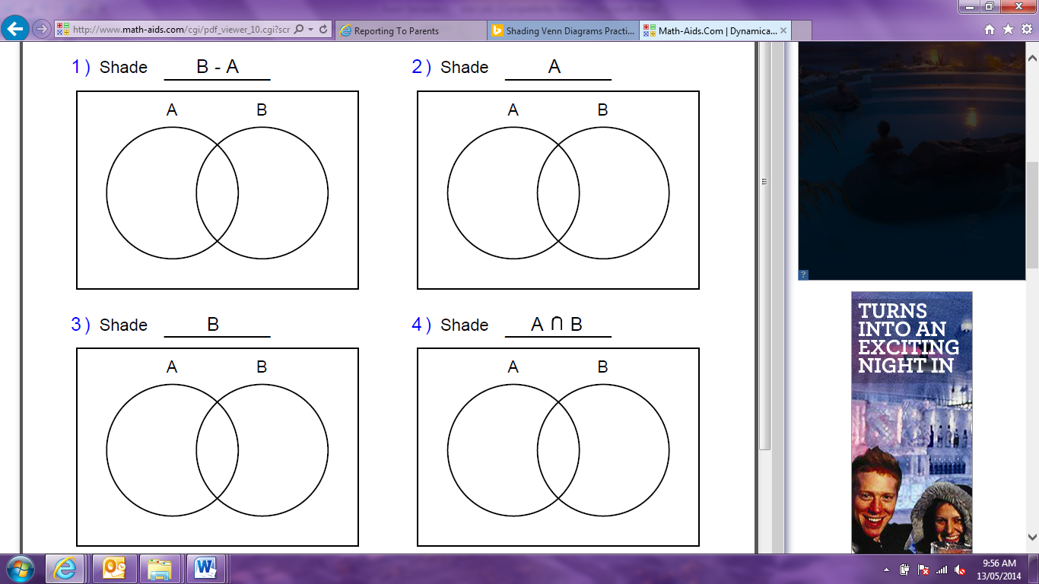

Shade: A or B Shade: A and B




[4 marks]
- Expand and simplify each of the following.

[8 marks]

- A survey of a class of 44 Year 9 students found that 17 like Mathematics and 12 like English. Five students like both Mathematics and English.
  - Use the space provided to construct a Venn diagram to represent the survey results.

  - If one of the 44 students was randomly selected, find:

    - Pr(like Mathematics or English)

    - Pr(like Mathematics but not English)

[5marks]
- Simplify the expression using a combination of index laws.

Express your answer using positive indices only.

[4 marks]

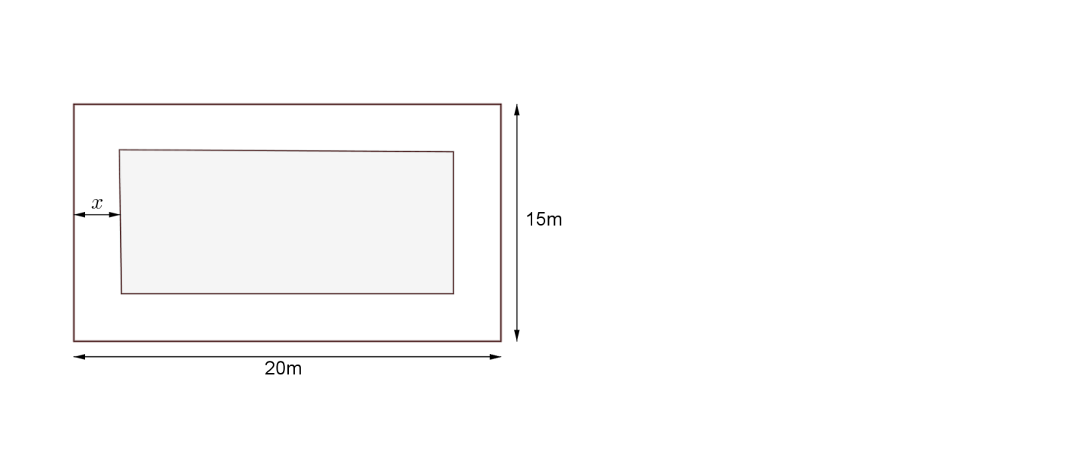
- The outside edge of a path around the lawn in a rectangular garden is 20m long and 15m wide. The path is $x$ metres wide.

  - Find the area of the garden

  - Find an expression for the area of the lawn in expanded form.

  - If the width of the path is 2m, what is the area of the lawn?

[6 marks]

[End of exam]

